**DAILY ONLINE ACTIVITIES SUMMARY**

|  |  |  |  |  |  |  |  |  |
| --- | --- | --- | --- | --- | --- | --- | --- | --- |
| **Date:** | **28/06/2020** | | | | | **Name:** | **Shailashree** | |
| **Sem & Sec** | **IV sem & B section** | | | | | **USN:** | **4AL18CS077** | |
| **Online Test Summary** | | | | | | | | |
| **Subject** | | **-** | | | | | | |
| **Max. Marks** | | **30** | | **Score** | | | **-** | |
| **Certification Course Summary** | | | | | | | | |
| **Course** | **Blockchain Basics** | | | | | | | |
| **Certificate Provider** | | | **Greatlearning academy** | | **Duration** | | | **2.5hours** |
| **Coding Challenges** | | | | | | | | |
| **Problem Statement1:** -------------------------------------------------------- | | | | | | | | |
| **Status: No Executed** | | | | | | | | |
| **Uploaded the report in Github** | | | | | **N0** | | | |
| **If yes Repository name** | | | | | **----** | | | |
| **Uploaded the report in slack** | | | | | **YES** | | | |

Online Test Summary: No internals conducted today.

Online Certification Course Summary: In today’s session I have learnt what are the different entity which are applied in blockchain Project and how it works.in the society and how blockchain solves the current problems and I came to know that it is not controlled by the user.

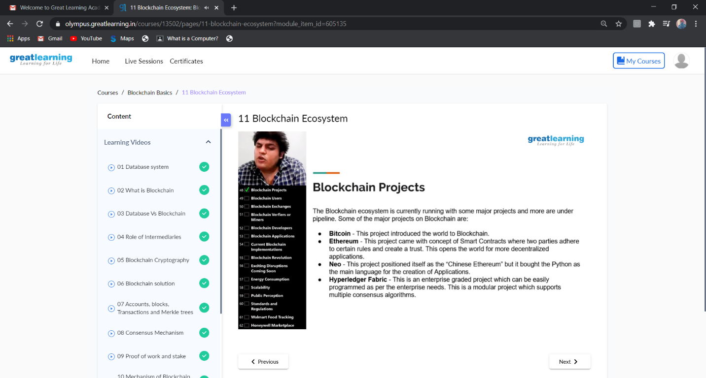

These are the snap shots of today’s sessions.

Online Coding Summary: No programs were given today.